**Project Design Phase-II**

**Data Flow Diagram &User Stories**

|  |  |
| --- | --- |
| Date | 23 -10 - 2022 |
| Team ID | PNT2022TMID44123 |
| Project Name | **AI-Powered Nutritional Analyzer for Fitness Enthusiasts** |
| Maximum Marks | 4 Marks |

**Data Flow Diagrams:**

A Data Flow Diagram (DFD) is a traditional visual representation of the information flows within a system. A neat and clear DFD can depict the right amount of the system requirement graphically. It shows how data enters and leaves the system, what changes the information, and where data is stored.

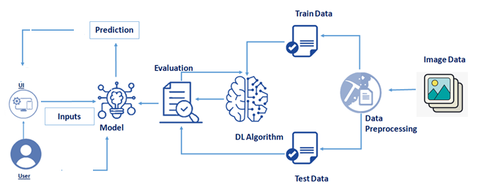

**User Stories**

Use the below template to list all the user stories for the product.

| **User Type** | **Functional Requirement (Epic)** | **User Story Number** | **User Story / Task** | **Acceptance criteria** | **Priority** | **Release** |
| --- | --- | --- | --- | --- | --- | --- |
| Customer (Mobile user) | Registration | USN-1 | As a user, I can register for the application by entering my email, password, and confirming my password. | I can access my account / dashboard | High |  |
|  |  | USN-2 | As a user, I will receive confirmation email once I have registered for the application | I can receive confirmation email & click confirm | High |  |
|  |  | USN-3 | As a user, I can register for the application through Facebook | I can register & access the dashboard with Facebook Login | Low |  |
|  |  | USN-4 | As a user, I can register for the application through Gmail | I can access my account / dashboard | Medium |  |
|  | Login | USN-5 | As a user, I can log into the application by entering email & password | I can access my dashboard | High |  |
|  | Dashboard | USN-6 | As a user, I can capture the image of the fruit use capture option | Through which I can get the nutrition present in the fruit | high |  |
| Customer (Web user) | Registration/Login | USN-7 | As a user, I can register for the application by entering my email, password, and confirming my password. | I can access my account / dashboard | high |  |
| Customer Care Executive |  | USN-8 | As a customer care executive I can resolve the login issues or any issue of the customer | I can provide support for 24X7. | medium |  |
| Administrator | Application | USN-9 | As an administrator I can update the application | I can resolve the bugs which arises for the users of the app | medium |  |